**Lab # 10**

**COMPONENT DIAGRAM**

**AND**

**DEPLOYMENT DIAGRAM**

***Aim:*** Draw component diagrams assuming that you will build your system reusing existing components along with a few new ones.

***Theory:***

**Component Diagram Notation**

* Components are shown as rectangles with two tabs at the upper left
* Dashed arrows indicate dependencies
* Circle and solid line indicates an interface to the component

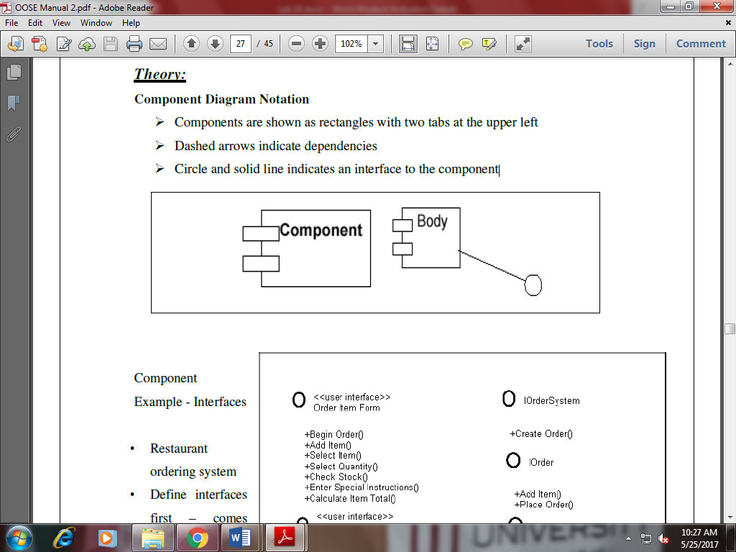

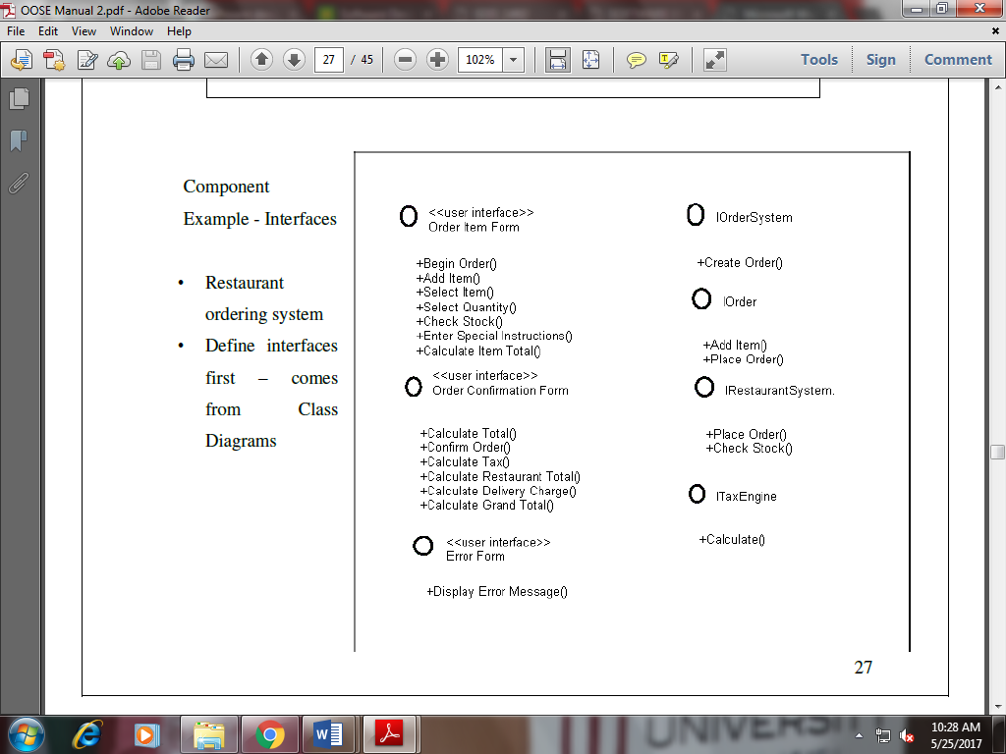

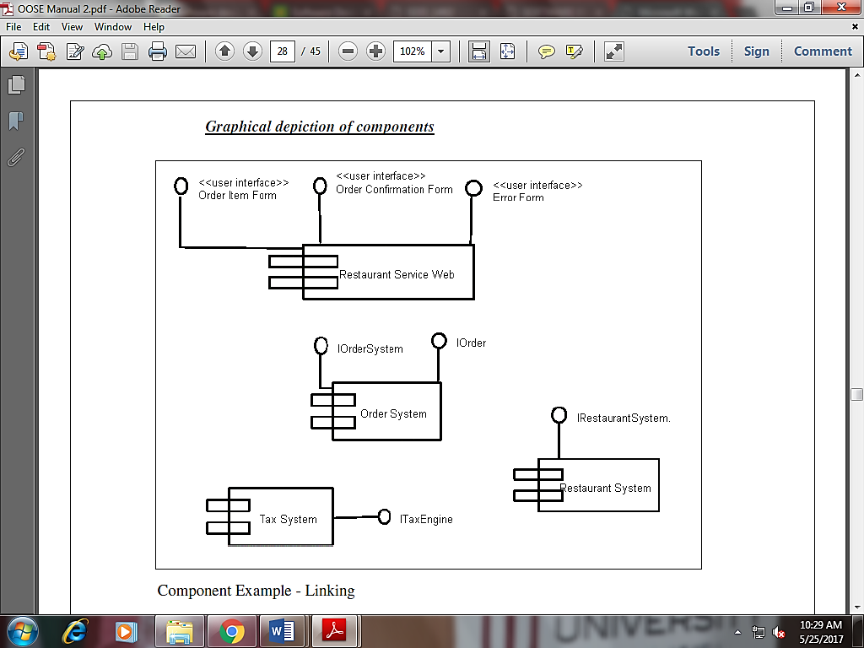

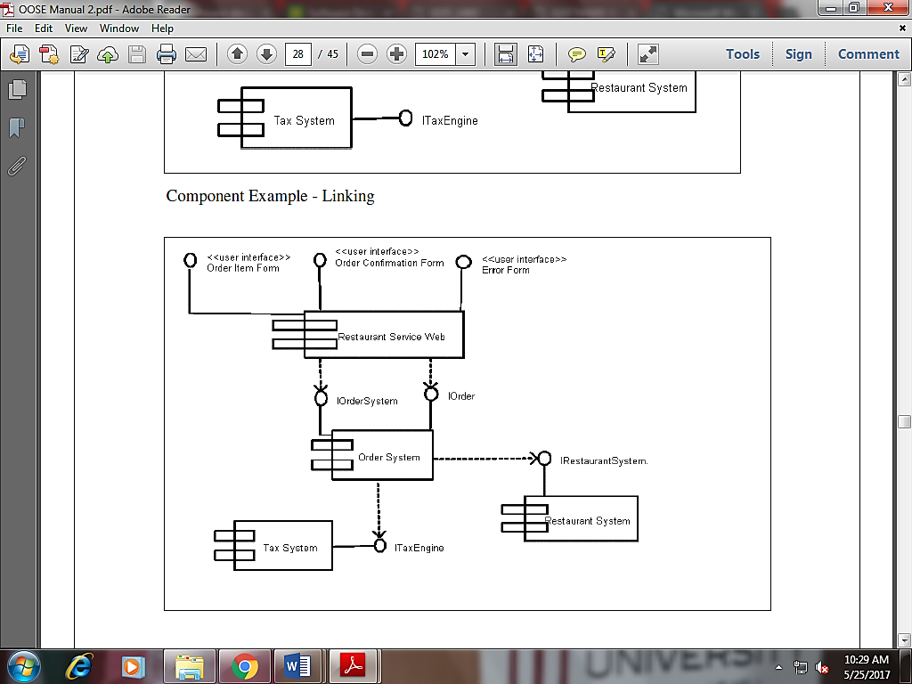

**Deployment Diagram**

***Aim:*** Draw deployment diagrams to model the runtime architecture of your system.

***Theory:***

* Shows the physical architecture of the hardware and software of the deployed system Nodes
* Typically contain components or packages
* Usually some kind of computational unit; e.g. machine or device (physical or logical)
* Physical relationships among software and hardware in a delivered systems
* Explains how a system interacts with the external environment

**Deployment Diagram for ATM system**

* A deployment diagram shows the relationship among software and hardware components in the delivered system.
* These diagrams include nodes and connections between nodes.
* Each node in deployment diagram represents some kind of computational unit, in most cases a piece of hardware.
* Connection among nodes show the communication path over which the system will interact.
* The connections may represent direct hardware coupling line RS-232 cable, Ethernet connection, they also may represent indirect coupling such as satellite to ground communication**.**

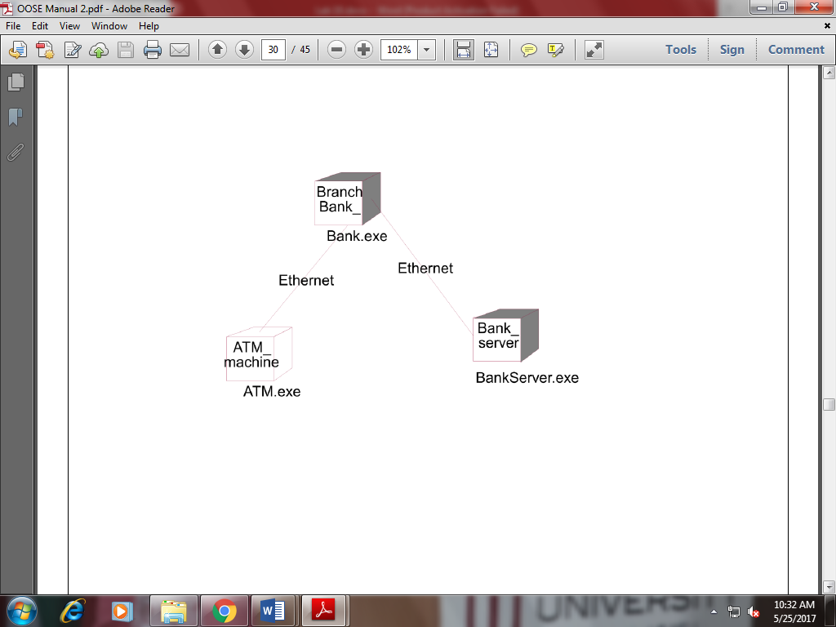

**Lab Task:**

1. Draw component Diagram for ATM machine
2. Draw component Diagram for Library Management
3. Draw deployment Diagram for ATM machine
4. Draw deployment Diagram for Library Management